1. Introduction and Background

1.1 Statement of Problem Area
With large volumes of transactions taking place in the courier / shipment sectors it is difficult to estimate the exact time of arrival of goods at its destination. The project attempts to create a web-based solution for tracking system and automatic inventory (package) management system.

1.2 Previous Work
Intelligent systems for tracking packages provide customers with innovative and affordable vehicle tracking solutions. GPS tracking technology is the standard in fleet management .It is an excellent way for fleet managers to monitor their trucks. Information about the package is as important as the package itself. The tracking system allows customers to monitor the shipment, the real time data helps the service or logistic company tightly manage its assets. It also involves huge sorting facilities and fleet management. The tracker produces a detailed routing label. The specially designed bar-code label contains a huge amount of information The trackers database gets regularly updated with the latest inputs
There are many inventory management systems and tracking systems, such as Advantrack Shadow Tracker, Verizon Fleet Administrator and Networkfleet GPS Tracking System etc. Some of the features are described in the following.

Advantrack Shadow Tracker is designed for small company fleets with basic vehicle tracking needs and for executives and independent contractors who want an automatic record of trip mileage, time, and travel records with no monthly fees. It is an economical, entry-level GPS vehicle tracking system showing vehicle location, entire route traveled, stops made, and speed of the vehicle.
Shadow Tracker has the ability to sniff out areas of low productivity within your mobile workforce. The Shadow Tracker is designed to help smaller, more budget-conscious companies to track the daily activities of their mobile vehicles and to protect businesses against time sheet fraud and unauthorized use of company vehicles. Simple to install and use, it allows comprehensive GPS tracking.
Shadow Tracker Working:
- The day's field activities are recorded by the built-in GPS receiver, stored, and automatically downloaded into your computer through the easy-to-use software.
- A summary of the day's activities is printed out with detailed maps and reports displaying actual stops, customer locations, mileage traveled, and elapsed time at each location.
- GPS technology verifies field data. By comparing field data with GPS reports, the Shadow Tracker accurately verifies daily field activity for important accounting functions such as job costing, payroll, and customer billing.

Features and Benefits
- Highly concealable within a vehicle
- Actively tracking and managing field personnel
- Reducing labor costs and overtime
- Providing independent verification of all field data
- Reducing overtime hours for accounting staff
- Tracking activities of your mobile personnel via GPS
- Providing enough memory to record all travel data for months
- Featuring GPS differential
- Cutting mobile fleet costs
- Heading off customer service complaints
- Improving motion accuracy with switched power

Networkfleet GPS Tracking System merges GPS technology with affordable wireless coverage. The result is easily accessible information on a vehicle's location, stops, idling and mileage that can be quickly analyzed to yield benefits in efficiency and cost reductions. The operations side of your business can make your fleet run more smoothly by accessing GPS location information.
Features of Networkfleet's GPS Tracking System:
- Get 2-minute update rates of current location
- View the historical track of a particular vehicle or fleet
- Get driving directions
- Find the closest vehicle to an address or landmark
- Detailed reporting - See Reporting Section
- Nationwide Coverage

Terrestrial Coverage
Networkfleet's data is transmitted over the Velocita Mobitex network which enables Networkfleet to deliver a truly nationwide service. Mobitex covers over 93% of the U.S. business population and operates in virtually every major metropolitan area. Because Mobitex is a data-only network, it does not compete with voice traffic. The Mobitex network allows our customers to access Networkfleet services whenever and wherever they need them.

Store and Forward Technology
Wireless coverage is excellent in most areas of the continental United States. However, in areas where there may be limited coverage, Networkfleet's "store and forward" feature limits impacts from coverage gaps. If a Networkcar-equipped vehicle enters an area of unreliable (or no) coverage, any unsent data is stored. All pending data is then uploaded to Networkfleet's website as soon as the vehicle travels back into the coverage footprint. Store and forward capability guarantees the accuracy of your tracking data even if contact is lost for brief periods.

1.3 Background
Radio Frequency Identification (RFID) Technology:
In general terms, RFID (Radio Frequency Identification) is a means of identifying a person or object using a radio frequency transmission. The technology can be used to identify, track, sort or detect a wide variety of objects. Communication takes place between a reader (interrogator) and a transponder (Silicon Chip connected to an antenna) often called a tag. Tags can either be active (powered by battery) or passive (powered by the reader field), and come in various forms including Smart cards, Tags, Labels, watches and even embedded in mobile phones. The communication frequencies used depends to a large extent on the application, and range from 125KHz to 2.45 GHz. Regulations are imposed by most countries (grouped into 3 Regions) to control emissions and prevent interference with other Industrial, Scientific and Medical equipment (ISM).
How RFID works

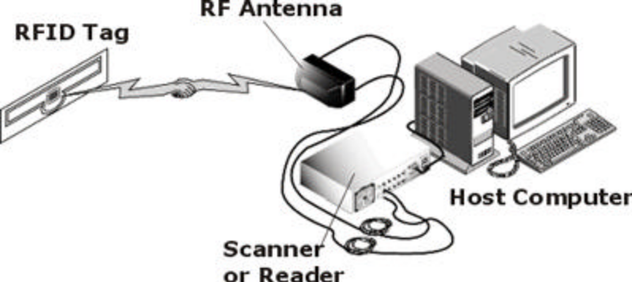
RFID Building Blocks

RFID Tags
Packaging
Every object to be identified in an RFID system will need to have a tag attached to it. Tags are manufactured in a wide variety of packaging formats designed for different applications and environments. The basic assembly process consists of first a substrate material (Paper, PVC, PET...), upon which an antenna made from one of many different conductive materials including Silver ink, Aluminum and copper is deposited. Next the Tag chip itself is connected to the antenna, using techniques such as wire bonding or flip chip. Finally a protective overlay made from materials such as PVC lamination, Epoxy Resin or Adhesive Paper, is optionally added to allow the tag to support some of the physical conditions found in many applications like abrasion, impact and corrosion.

Basic Tag Assembly
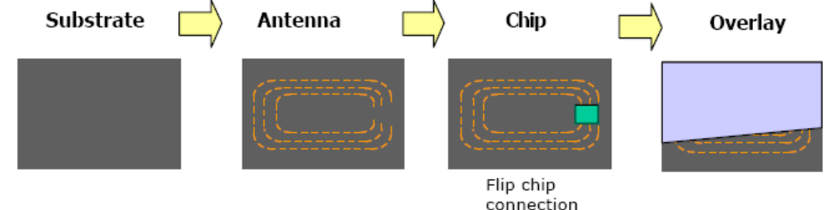

Examples of different formats
- Credit card size flexible labels with adhesive backs
- Tokens and coins
- Embedded tags – injection molded into plastic products such as cases
- Wrist band tags
- Hard tags with epoxy case
- Key fobs
- Tags designed specially for Palettes and cases
- Paper tags

Active and Passive Tags
- Passive tags use the reader field as a source of energy for the chip and for communication from and to the reader. The available power from the reader field, not only reduces very rapidly with distance ,but is also controlled by strict regulations, resulting in a limited communication distance of 4 - 5m when using the UHF frequency band (860 Mhz – 930 Mhz).
- Semi-Passive (battery assisted backscatter) tags have built in batteries and therefore do not require energy from the reader field to power the chip. This allows them to function with much lower signal power levels, resulting in greater distances of up to 100 meters. Distance is limited mainly due to the fact that tag does not have an integrated transmitter, and is still obliged to use the reader field to communicate back to the reader.
- Active tags are battery powered devices that have an active transmitter onboard. Unlike passive tags, active tags generate RF energy and apply it to the antenna. This autonomy from the reader means that they can communicate at distances of over several kilometers.

RFID Readers
Readers or interrogators as they are sometimes called, are a key element in any RFID system, and will therefore be part of the product evaluation and selection process. Up until the recent surge in developments for the supply chain and EPC tags, readers were mainly used in access control systems and other low volume RFID applications, which meant that the problem of treating very large numbers of tags and high volumes of data was not such a serious issue. This is now of course all changing, and many reader manufacturers are starting to develop next generation products to handle the application problems that will be specific to the supply chain and EPC infrastructure.

Global Positioning System (GPS)
GPS is the shortened form of NAVSTAR GPS. This is an acronym for NAVigation System with Time And Ranging Global Positioning System. The Global Positioning System (GPS) is a worldwide radio-navigation system formed from a constellation of 24 satellites and their ground stations. GPS uses these "man-made stars" as reference points to calculate positions accurate to a matter of meters. In fact, with advanced forms of GPS you can make measurements to better than a centimeter! In a sense it's like giving every square meter on the planet a unique address.
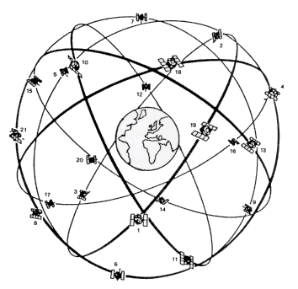
GPS receivers have been miniaturized to just a few integrated circuits and so are becoming very economical. And that makes the technology accessible to virtually everyone. These days GPS is finding its way into cars, boats, planes, construction equipment, movie making gear, farm machinery, even laptop computers.

GPS works in five logical steps:
- The basis of GPS is "triangulation" from satellites.
- To "triangulate," a GPS receiver measures distance using the travel time of radio signals.
- To measure travel time, GPS needs very accurate timing which it achieves with some tricks.
- Along with distance, you need to know exactly where the satellites are in space. High orbits and careful monitoring are the secret.
- Finally you must correct for any delays the signal experiences as it travels through the atmosphere.

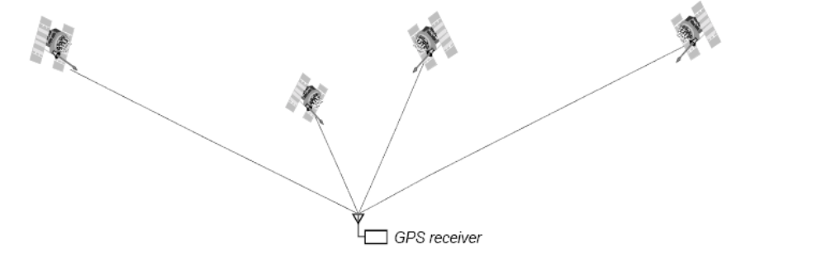
Typical GPS Satellite Constellation

GPS approximates your position using a technique called "three-dimensional trilateration," which is the process of locating the point where spheres intersect in three-dimensional space. If you know you are 10 miles from satellite A in the sky, you could be anywhere on the surface of a huge, imaginary sphere with a 10-mile radius. If you also know you are 15 miles from satellite B, you can overlap the first sphere with another, larger sphere. The spheres intersect in a perfect circle. If you know the distance to a third satellite, you get a third sphere, which intersects with this circle at two points. As more spheres are added, the point of intersection becomes more precise.
Both the GPS receiver and the GPS satellite are repeating a complex binary pattern called a "Pseudo-Random Code" (or "PRC" for short), like two CD players playing the same CD at the same time, but in different locations. The PRC, transmitted as a radio signal, takes time to travel from the satellite to your position, even at the speed of light. When it arrives, the PRC is slightly lagging behind the local PRC repeating inside of the receiver. The lag time is the time taken to send the signal. By multiplying that time by the speed of light, the distance to the satellite is now known. This process is repeated for as many satellites as can be located. When at least four satellites' distances are known, trilateration is performed. Due to disturbances caused by the atmosphere and gravitational effects of the moon and Sun, the receiver sometimes has to adjust the distances until an intersection occurs.

General Packet Radio Service (GPRS)
The General Packet Radio Service (GPRS) is a new nonvoice value added service that allows information to be sent and received across a mobile telephone network. It supplements today's Circuit Switched Data and Short Message Service. GPRS is NOT related to GPS (the Global Positioning System), a similar acronym that is often used in mobile contexts. GPRS has several unique features which can be summarized as:
- SPEED
Theoretical maximum speeds of up to 171.2 kilobits per second (kbps) are achievable with GPRS using all eight timeslots at the same time. By allowing information to be transmitted more quickly, immediately and efficiently across the mobile network, GPRS may well be a relatively less costly mobile data service compared to SMS and Circuit Switched Data.
- IMMEDIACY
GPRS facilitates instant connections whereby information can be sent or received immediately as the need arises, subject to radio coverage. No dial-up modem connection is necessary. This is why GPRS users are sometimes referred to be as being "always connected". High immediacy is a very important feature for time critical applications such as remote credit card authorization where it would be unacceptable to keep the customer waiting for even thirty extra seconds.
- SERVICE ACCESS
To use GPRS, users specifically need:
- A mobile phone or terminal that supports GPRS (existing GSM phones do NOT support GPRS)
- A subscription to a mobile telephone network that supports GPRS
- Use of GPRS must be enabled for that user. Automatic access to the GPRS may be allowed by some mobile network operators, others will require a specific opt-in
- Knowledge of how to send and/ or receive GPRS information using their specific model of mobile phone, including software and hardware configuration (this creates a customer service requirement)
- A destination to send or receive information through GPRS. Whereas with SMS this was often another mobile phone, in the case of GPRS, it is likely to be an Internet address, since GPRS is designed to make the Internet fully available to mobile users.

Wireless Fidelity (WiFi)
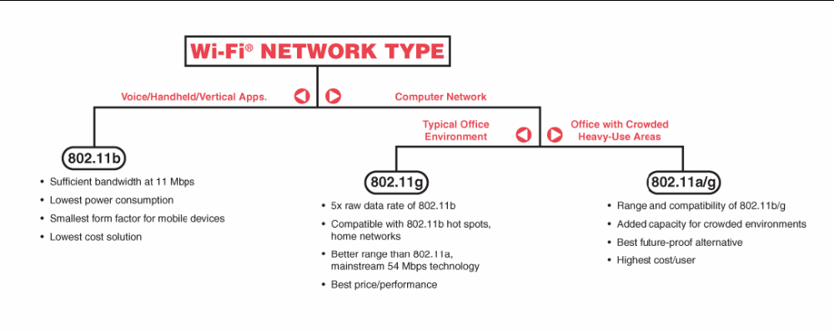
WiFi is the wireless way to handle networking. It is also known as 802.11 networking and wireless networking. The big advantage of WiFi is its simplicity. You can connect computers anywhere in your home or office without the need for wires. The computers connect to the network using radio signals, and computers can be up to 100 feet or so apart.

There are two main components to a WiFi network. First, you will need an "access point" (called the "base station" with Apple's Airport technology). Second, you will need a network card installed in your computer. Once you have the access point configured and the network card installed, you can transmit data from your computer to the base station up to 150 feet away at 10 MBps with no cables

Things to Consider When Using WiFi Although
WiFi definitely has its advantages, one must take a few things into consideration when building their wireless network.
Security – By virtue of being wireless, a WiFi network is less secure than a hard-wired network. Because of this it is easier for snoopers to get onto your network and possibly access your data. Proper configuration and use of firewalls and encryption methods can help mitigate these problems.
Placement – Many cordless phones operate on the same frequency as 802.11b access points and can cause interference when used. You should also avoid placing your access point near microwave ovens for the same reason. If possible you should also find the path of least resistance from the access point to the computer, going through the least amount of walls possible.

Extensible Markup Language (XML)
XML is a markup language for documents containing structured information. Structured information contains both content (words, pictures, etc.) and some indication of what role that content plays (for example, content in a section heading has a different meaning from content in a footnote, which means something different than content in a figure caption or content in a database table, etc.). Almost all documents have some structure. A markup language is a mechanism to identify structures in a document. The XML specification defines a standard way to add markup to documents.

Why XML?
XML was created so that richly structured documents could be used over the web. The only viable alternatives, HTML and SGML, are not practical for this purpose. HTML comes bound with a set of semantics and does not provide arbitrary structure. SGML provides arbitrary structure, but is too difficult to implement just for a web browser. Full SGML systems solve large, complex problems that justify their expense. Viewing structured documents sent over the web rarely carries such justification.

1.4 Purpose / Objective / Justification of Project
This project is a web-based system for fleet tracking / management and also provides automatic inventory management functionality. With large volumes of transactions taking place in the courier / shipment sectors it is difficult to estimate the exact time of arrival of goods at its destination.
For example if we are using the FedEx / DHL / UPS services, we are provided with a tracking number which only tells us whether the package has left for its destination. Tracking numbers are used by the service provider to identify and trace every package as it moves through the system to its destination. The service provider automatically assigns a tracking number to the package.
The package cannot be scheduled to arrive at a specific time of day. The packages usually arrive anytime from Monday through Friday. This makes it impossible to determine when the package is going to arrive.
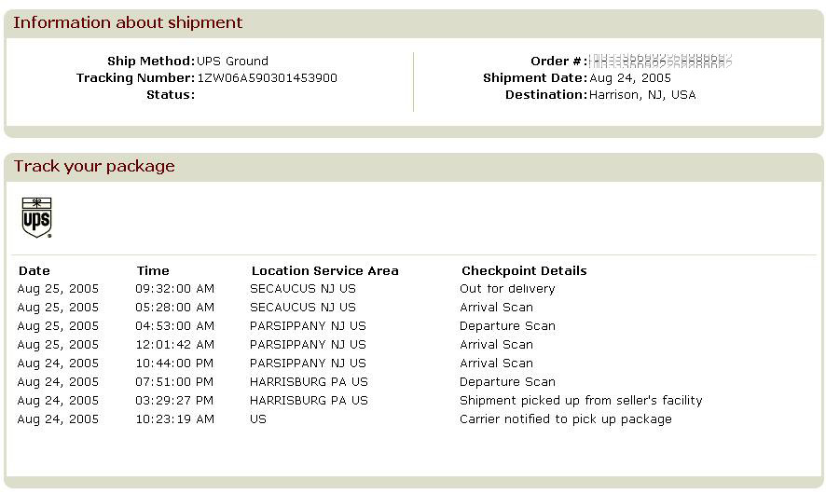

Package Arrival Time:
UNKNOWN

Web Based Tracking System via the GPS is a cost effective and efficient way of tracking and pin pointing the exact location of the goods. This helps in calculating the distances between the current location and the final destination. A GPS based vehicles tracking system provides real time tracking of the vehicles thus providing a time saving mechanism to the customers.
Technology provides them to keep almost continual tabs on shipments. Accurate info of inventory in transit could actually replace inventory on how to replace inventory with and to cut down in working capital there is a need for real time info about the product and its status in transit. As a result tracking technologies-from basic bar coding to sophisticated satellite and cellular communications, are driving supply chain design
With the growth of cellular technology carriers can use a mix of satellite and cellular communication systems GPS technology is used to track and then there is transfer of data via radio waves RFID system includes three key components; tag, antenna, reader. Attached to the items to be tracked, the tags contain intelligent agents that are pre-programmed with data about the object. That data is gathered directly by the readers and is transmitted by radio waves to the host computer.
The package associated to a specific truck is automatically updated into the database with the help of RFID. Each package is attached with a RFID chip and every time a package is scanned with a RFID reader, information such as truck number is associated with the package automatically updated in the database.

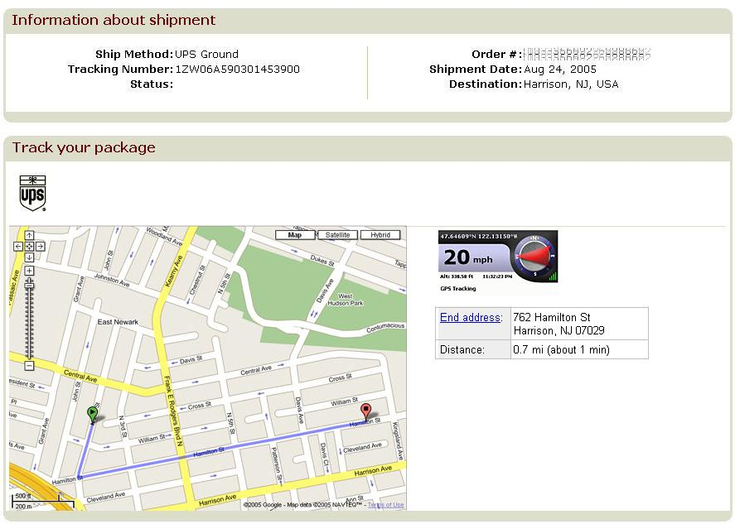

Potential Contribution:
This project will provide a fleet management to the companies that need to track the whereabouts of their vehicles. With the help of this application it would be possible for a customer to co-ordinate the pickup of the package and also provide the company to direct the employee or to provide the employee with an emergency service should they be in trouble.

Expected Outcomes:
Tangible assets:
Companies in the logistics sector use IT extensively to track goods. Among top technology applications E-Commerce is a important and priority application. This provides a transparent supply chain mechanism that helps logistics companies track goods. This ensures timely delivery connectivity is a high priority area and firms have realized the importance and need for these kind of services .Most logistics firms have therefore allocated a sizable portion of their budget to bandwidth allocation.

Results:
This service helps reduce the costs by automating the manual process of checking the status of materials transported by trucks to multiple job sites. Importantly it provides detailed reports on truck and item location all available via the web 24/7. At the distribution centre it eliminates the need to manually check the status of a customer order.
Due to the Net based technology start up the maintenance costs are minimal. This service can be hosted on its own servers and can be accessed through an Internet browser.
Users can track materials from the time it is picked up, staged at the distribution centre, loaded in to the outbound truck and delivered. Each of the items have tracking numbers bar codes attached to them for scanning at each point thus enabling real time status reporting available to them via the web 24/7.

Dissemination to the customer:
This service is a provider of real time fleet management solutions for small to large transportation and logistics companies. It allows users to log in from any PC to access real time information on specific vehicles. This system generates critical information through GPS, such as speeding, unauthorized stoppages and emergency SOS alerts.

2. System Functional Specification
[GPS Satellites] [GPS Satellites] [GPS Satellites] [GPS Satellites]
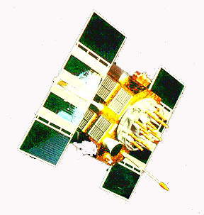

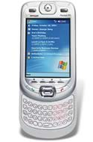
Truck 1
Truck 2
[Sends Lat, Long Co-ordinates] [Sends Lat, Long Co-ordinates]
Internet

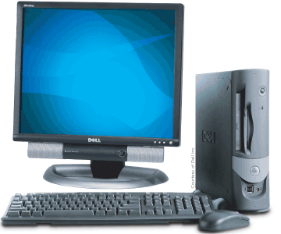
Request “ks00091”
Request “ks00092”


“Lat: 40.23445,Long: -11.23455” “Lat: 40.23445,Long: 78.380533”

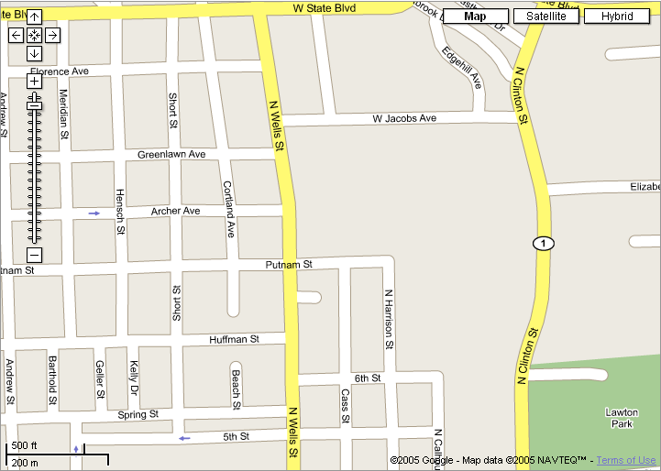
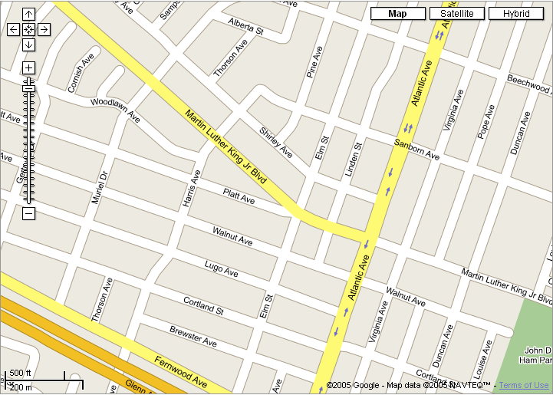

2.1 Functional Specification
The system is responsible for providing several core functions, such as fleet management / tracking and real-time data storage and retrieval. Details of these functional areas are further described in the sections below.

2.1.1 Functions Performed
The system provides inventory management facility. Every vehicle is provided with a RFID reader and each package is provided with a unique RFID tag. As each package is moved into the vehicle, the RFID reader embedded in the truck reads the unique RFID associated with the package and updates in the database and the vice-versa.

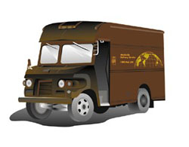
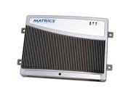
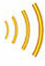
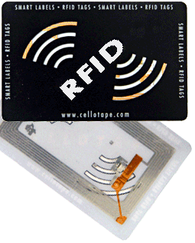
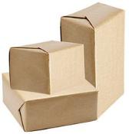

Fleet Management functionality; here each truck is embedded with a GPS device which at regular interval of time sends it’s coordinates to the server where the end-user can locate the vehicle. These GPS devices are connected to the central server via internet using GPRS or 3G and the coordinates are sent and stored in the database.
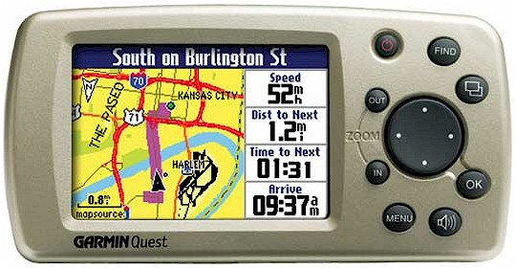
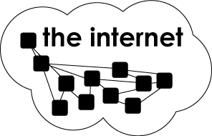
Latitude, Longitude

3G / GPRS

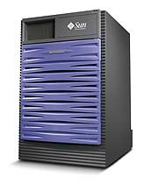

Database

_{Server}
Web User Interface: Each user is provided with a tracking number of their package. By entering the tracking number the customer is able to know on which truck his particular package is and also the exact location of the truck and thus helping him to determining the approximate time of arrival.

Database
Lat, Long?

_{Lat, Long}

Data Security: The web server is equipped with digital certificates and with 128bit SSL encryption. The browser checks the certificate to make sure that the site you are connecting to is the real site and not someone intercepting.
Step 1: Determine Secure Communication
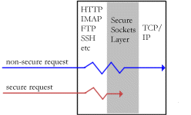

Step 2: The SSL Hand shake
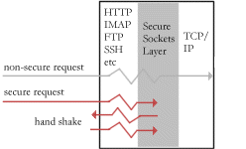
Step 3: Completing The SSL Hand Shake
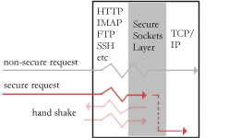

2.2 System Data Base / File Structure Preview

RFID_Info Table
RFID_No | P_Number | Flag_No

P_Number | S_C_Name | S_C_Add | D_C_Name | D_C_Add | P_Desc

Package_Info Table

Truck_Geo Table
Truck_No | Latitude | Longitude

Truck_Track Table
Truck_No | Tracking_No

Tracking_No | P_Number
Track_Info Table

2.3 External and Internal Limitations and Restrictions
The system will have the following limitations:
- The packages embedded with RFID identifier have a limited radio range. Hence the RFID reader will not be able to read the unique RFID number associated with the package if it’s out of range.
- GPS signals could get week and would lead to signal loss incase of any obstruction.
- While using GPRS as a means of connecting to internet, the speeds are much lower in reality when compared to theoretical speed of 172.2 kbps and transit delays.

3. System Performance Requirements
3.1 Efficiency
The efficiency of the system depends on following factors:
- Server: The server has to handle multiple connections at any point of time and the data traffic between the client and server is transmitted over a secure channel (SSL) there is an extra overhead which eventually affects the efficiency of the system.
- Server Program: Since the server program has to parse the GPS coordinates, the RFID tags number and update the database; there is a lot of processing overhead and hence affecting the overall performance of the system.
- Web Services: The system utilizes mainly two web services. First one being Microsoft Virtual Earth (Windows Live Local) which provides digital map services and other one being Reverse Geocoding provided by iMapTools.com which helps in getting the Street Address when provided with GPS coordinates. The efficiency of our system heavily depend upon the availability and server response time of these two web service providers.

3.2 Reliability
3.2.1 Description of Reliability Measures
- Wireless Connectivity (GPRS): The crucial component for the system to function as per the specification i.e. to update the coordinates (GPS) at regular intervals is by over the internet. Since the mobile wireless technology is still in its development stage such as 3G and EV-DO (wireless broadband), the use of GPRS is unreliable due to a service coverage range and connectivity.
- GPS Coordinates: Even though there is no limit in the service range of GPS satellites getting the ‘precise’ coordinates is practically not possible due to atmospheric interference and other factors. GPS signals could get week and would lead to signal loss incase of any obstruction which decreases reliability of GPS coordinates.
- Digital Maps: Digitals Maps service provided by Microsoft, Google, Mapquest, NASA (World Wind) etc. all have different ways of interpreting the GPS coordinates and hence applying the coordinates onto a digital map varies depending upon the service provider.
- Web Service: Since the web services (Digital Maps and Reverse Geocoding) are provided by third party, there is no guarantee for the 100% uptime of the server and the web services availability.

3.2.2 Allowable / Acceptable Error / Failure Rate
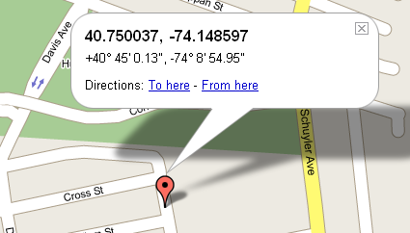
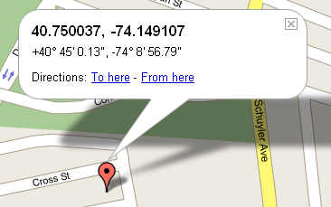
- The precision of the GPS coordinates being displayed onto a digital map is approximate and hence there will always be an error when being displayed onto a map.
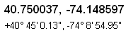

(Actual Location of Digital Map) (Position being displayed on Map)
- Since the client system connects to the internet via GPRS to update the coordinates, getting connectivity is not assured due to factors such as service range and signal strength. Hence the system cannot expect minute by minute update of the coordinates.
- Reverse Geocoding i.e. getting address from a GPS coordinates, is only possible if the coordinates is valid i.e. its not possible to determine the address of a vehicle when traveling on a interstate or highway which the web services sends as a exception, which our system ignores and displays no address for that specific coordinate.

3.3 Security
3.3.1 Data Security
- The web server is equipped with digital certificates and with 128bit SSL encryption. The browser checks the certificate to make sure that the site you are connecting to is the real site and not someone intercepting. Browser and sender sends each other unique codes when scrambling (or encrypting) the information that will be sent. The browser and server start talking using the encryption, the web browser shows the encrypting icon, and the web pages are processed secured.
- The technical security offered by GPRS is very similar to that offered by GSM. Security such as Identity Confidentiality, Identity authentication, Confidentiality of both user data and signaling (between mobile and GPRS serving node) is provided. Thus sending GPS coordinates and RFID tag details over the internet via GPRS is secure and need not be encrypted.

3.4 Maintainability
The only maintainability issue in this system is the hardware (GPS device and RFID device). When considering the software, with many built in classes provided my .NET framework, maintenance of the system is pretty simple since there is only small amount of code that has to be reviewed.

3.5 Modifiability
Object oriented approach has been used to develop the project, the code is well organized. And with many built in classes provided by .NET framework and with lesser lines of code modifying the code is simple and easy to understand.

3.6 Portability
The project can be implemented only in Windows machines. For all Windows machines, a setup package is implemented which either installs a fresh copy onto the destination machine or updates the existing software based on user requirements.

4. System Design Overview
4.1 System Data Flow Diagram

Input Output
RFID Reader
Phidget RFID
Interface

System Time_Ticker
Internet / Server

GPS Device
GPS.NET Interface

Phidged RFID Interface:

Input Phidget RFID Interface Output
OnTagRead

RFID Reader
OnAttach
OnError
Rfid_DataList Array

MsgBox “error”

GPS.NET Interface:

Input GPS.NET Interface Output

GPS Device
OnAttach
GpsDevice_SentenceReceived
GpsDevice_PositionChanged
Gps_satelliteSignalBar
Gps_satelliteviewer

Gps_DataList Array

4.2 System Data Dictionary
Phidget RFID package mainly consists of the following elements.
Interop.PHIDGET.dll | The COM interop DLL for integrating the Phidget Interface driver.
String GetLastTag (); | Returns the last tag that the reader has registered.
bool IsAttached (); | Returns a bool indicating the status of the device.
event DetachEventHandler Detach; | Occurs when the device is unplugged, or closed from software.
OnTag(ByVal TagNumber As String) | Gets the tag number from the GetLastTag().
m_OnError(ByVal PHIDGET As PHIDGET.IPhidget, ByVal Description As String, ByVal SCODE As Integer) | Returns a error code returned from the RFID reader.

GPS package consists of the following elements
Satellite | Represents information about a GPS satellite in orbit above Earth.
SatelliteEventHandler | Facilitates events and asynchronous calls which use an Satellite object as a parameter.
NmeaSentence | Represents a single NMEA-0183 sentence
NmeaSentenceEventArgs | Represents information about raw data received from a GPS device.
SatelliteCollection | Represents information about all detectable GPS satellites.

4.3 Equipment Configuration
Hardware Configuration:
The project uses a GPS device, RFID device and a GPRS PCMCIA slot card. The GPS and RFID device connects via USB and requires no configuration. The GPRS PCMICA card requires a device driver which is installed during the installation of the Client Software.

Software Configuration:
IIS (Internet Information Services) needs to be setup in-order to support ASP.NET.
Step 1: First the TCP port has to be set to Port 80
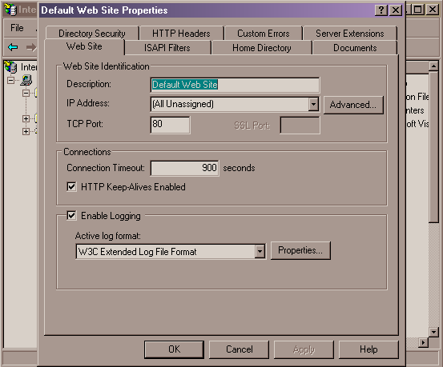

Step 2: To enable secure communication (SSL) we need to install server certificates
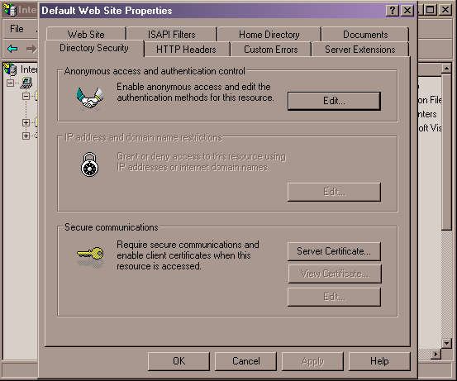

4.4 Implementation Languages
The project has been developed in .NET (C# / VB.NET / ASP.NET) languages as the development time is quicker with the facilities of many inbuilt classes. This makes maintainability and modifiability easy.

4.5 Required Support Software:
- Phidget RFID Interface: This provides a interface of reading the Phidget RFID tags. The software component reads the raw data bits from the reader and converts to user readable tag numbers.
- Stormsource GPS.NET: GPS.NET uses a multi-threaded detection technique to quickly locate devices. Real-time GPS data is automatically converted into objects then provided to your application via several events.

5. System Data Structure Specification
5.1 Other User Input Specification
Most of the operation performed are automatic and requires no user input except for tracking the location of the truck / vehicle by the end-user. Once the user enters into the main page, he would be asked to enter the tracking number after which he would be redirected to another page displaying the position of the vehicle and distance and approximate time of arrival.

5.1.1 Data Format / Syntax
Data Format for Communication between GPS/RFID Client and Server
For GPS : Syntax: Truck_Number, Latitude, Longitude, Date_Time
For RFID: Syntax: RFID, RFID_Tag_Number
Example:
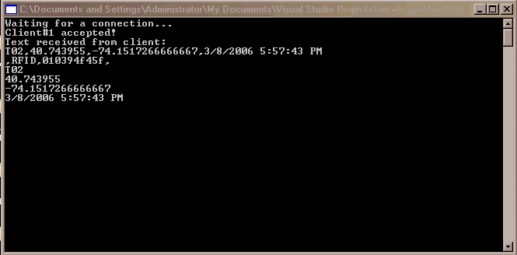

5.2 System Data Dictionary

RFID_Info Table
RFID_No | P_Number | Flag_No

P_Number | S_C_Name | S_C_Add | D_C_Name | D_C_Add | P_Desc

Package_Info Table

Truck_Geo Table
Truck_No | Latitude | Longitude

Truck_Track Table
Truck_No | Tracking_No

Tracking_No | P_Number
Track_Info Table

5.2.1 Database Tables
5.2.1.1 RFID_Info
Data Item | Abbreviation | Type | Description
RFID_No | Radio Frequency Identification Number | Text | It’s the unique 10 Digit code assigned to all package.
P_Number | Package Number | Text | The package number that the RFID is associated with.
Flag_No | Flag Number | Integer | Flag number to indicate the following:  1 -> Sent for Delivery  2 -> Delivered

5.2.1.2 Product_Info Table
Data Item | Abbreviation | Type | Description
P_Number | Package Number | Text | It’s a unique number associated to every package.
S_C_Name | Source Customer Name | Text | Name of the customer whose mailed the package.
S_C_Add | Source Customer Address | Text | Address of the source customer.
D_C_Name | Destination Customer Name | Text | Name of the customer for whom the package is being shipped.
D_C_Add | Destination Customer Address | Text | Address of the destination customer.
P_Desc | Package Description | Text | Package information such as weight of the package etc.

5.2.1.3 Truck_Geo Table
Data Item | Abbreviation | Type | Description
Truck_no | Truck Number | Text | The unique number associated to each truck.
Latitude | Latitude | Integer | The geographical Latitude coordinates.
Longitude | Longitude | Integer | The geographical Longitude coordinates.

5.2.1.4 Truck_Track Table
Data Item | Abbreviation | Type | Description
Truck_no | Truck Number | Text | The unique number associated to a truck.
Tracking_No | Tracking Number | Text | A unique number that is given to track the packages.

5.2.1.5 Track_Info Table
Data Item | Abbreviation | Type | Description
Tracking_No | Tracking Number | Text | A unique number that is given to track the packages.
P_Number | Package Number | Text | It’s a unique number associated to every package.

6. Module Design Specification

6.1 Module Functional Specification

6.1.1 Functions Performed
GPS/RFID Client:
Purpose:
The main purpose of the module is to get the GPS and the RFID information and update the same in the database.
Inputs:
The only inputs are the inputs from the GPS device and the RFID device. The user initially selects the truck number and the rest is automatic.
Process:
At the start of the program the user has to select the truck number which will then get associated to that machine / vehicle. Once the GPS device is attached, the coordinates is retrieved using the GPS.NET component and the coordinates are parsed. There are mainly two functions, one being gps_sentencedreceived and gps_sentencedchanged. The gps_sentencedreceived, get the GPS coordinates from the GPS device and invokes the gps_sentencechanged and compares the current and the previous coordinates. If they are the same, then the sentenced is ignored else the sentenced is parsed and the coordinates are stored in a temporary variable. Everytime a RFID tag is swiped across the reader the tag number is stored in a datalist and if the same tag is swiped across the reader consecutively then the tag is ignored.

Output:
A timer is set for 60 seconds and at the end the software attempts to make a GPRS connection and send the coordinates and the RFID tag number if any to the server.

Server Program:
Purpose:
The only purpose of this program is to parse the incoming string i.e. GPS coordinates and RFID tag details and update the same in the database.
Inputs:
The GPS/RFID client sends the GPS coordinates and the RFID tag number.
Process:
The program is a multi-threaded program. This program on the server has to handle multiple clients sending the coordinates and the tag numbers at any point of time and since opening a database and closing the database takes a while, the threaded architecture takes care of the application for not freezing. The string that is sent by the client containing the coordinates and the tag numbers needs to be parsed and the program strips off the only important information such as the latitude, longitude, truck number and the date time and updates in the database.
Output:
The server only updates the database with the new coordinates and updates the state of the inventory associated with the RFID tag as either ‘delivered’ or ‘on delivery’.

7. System Verification
7.1 Items / Functions to be tested
The following are the list of items / methods that is to be tested
- The Digital Map precision of the GPS coordinates.
- The Reverse Geocoding precision of the GPS coordinates.
- The GPRS reliability.

7.2 Description of Test Cases
- For Digital Map precision of the GPS coordinates
We need to test the exact location of the vehicle on the Digital map (Microsoft Virtual Earth) based upon the incoming real-time coordinates.
- For Reverse Geocoding precision of the GPS coordinates
We need to test the efficiency and accuracy of the web services that provides the street address from a given GPS coordinates (Latitude and Longitude)
- For GPRS reliability
We need to test the reliability and probability of connecting to the internet. Internet connectivity via GPRS is a crucial component for the implementation of the project.

7.3 Justification of Test Cases
- For Digital Map precision of the GPS coordinates
This test is needed to check the location of the vehicle on the map since the GPS coordinates corresponding to the vehicle should be displayed on the appropriate region on the map i.e. we cannot expect the map to show the vehicle off road which is logically incorrect.
- For Reverse Geocoding precision of the GPS coordinates
Reverse Geocoding is a process of obtaining street address from GPS coordinates. It is important to know the accuracy of the address based on the coordinates. Different web services uses different algorithm to determine the approximate address. It is important to know what address is shown when the vehicle is at an intersection or elsewhere.
- For GPRS reliability
For the Client (GPS/RFID client) to update GPS coordinates and RFID tags number at regular interval of time when mobile, we need to connect to the internet via GPRS. Since internet is the only way to update the values in the database, GPRS becomes a crucial component. Hence determining the reliability and availability is important.

7.4 Test Run Procedure and Results
7.4.1 Digital Map Precision
Procedure: To determine the precision, the project was implemented at real-time and the coordinates was mapped onto a digital map. Once the GPS coordinates were obtained these coordinates were also mapped onto Digital Map Service providers namely Microsoft Virtual Earth, Google and Mapquest.

For Coordinates: Latitude: 40.743955 Longitude: -74.1517266666667
Google Output:
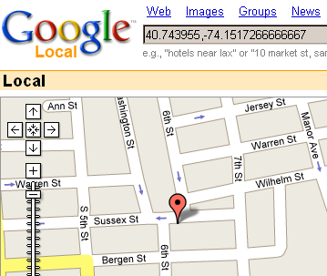

Mapquest Output:
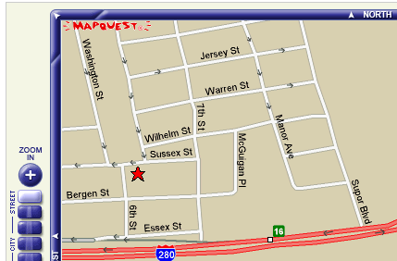

Microsoft Virtual Earth:
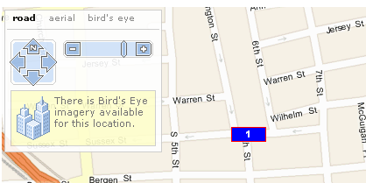

Result:
The closest point was with both Microsoft Virtual Earth and Google’s Map. Based on this result Microsoft Virtual Earth is used in this project.

7.4.2 Reverse Geocoding precision
Procedure: The web service provided by IMapTool.com which is used for Reverse Geocoding purposes is tested for accuracy and reliability. The output of this web service is XML which is parsed using XML Parser and the address is displayed.

For Coordinates: Latitude: 40.748187 Longitude: -74.154125
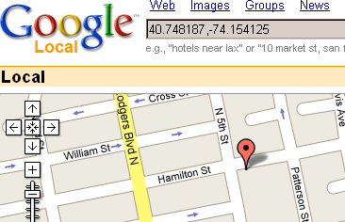
The Output received:
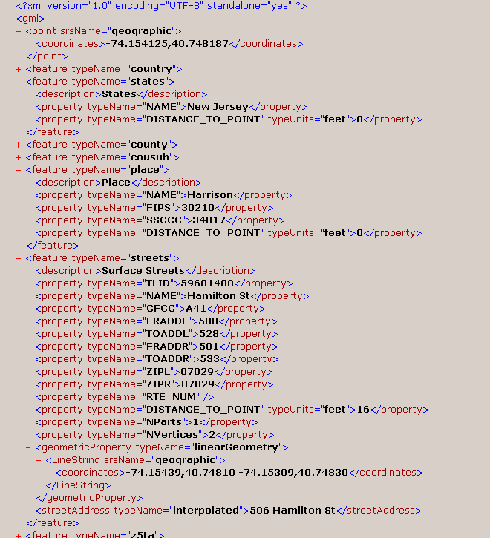
For Coordinates: Latitude: 40.743655 Longitude: -74.15176
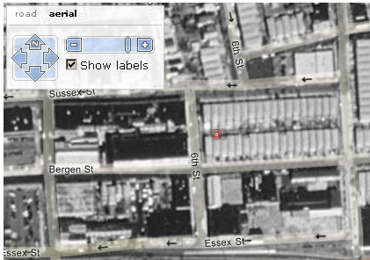
The actual address
602 Bergen St, Harrison, NJ - 07029
But displays
“360 6th St, Harrison, NJ – 07029”
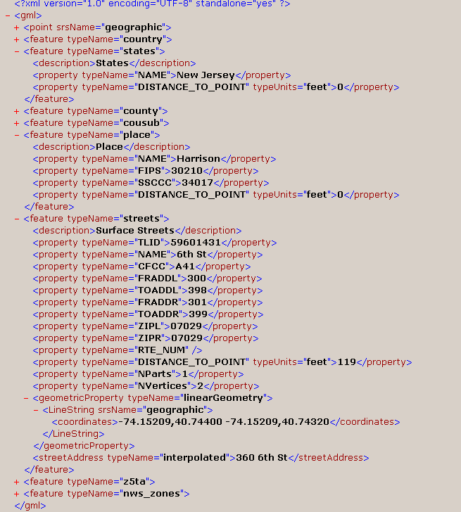
Result: The accuracy of the system (web service) is nearly the correct street address. The system is good since the GPS coordinates by themselves approximate values.

7.4.3 GPRS Reliability
Procedure: The only way to access the GPRS reliability is try to connect to the internet via the same. GPRS reliability is going to be tested in two scenarios, one in open space and other in enclosed space.
Results: At each scenario 10 attempts were made to connect to the internet. In the open space, there was 3 successful connection and 7 failures. In closed environment all 10 attempts was a failure. This high failure rate could be either because of week signal or number of slots available for GPRS connections in the base station is full.

8. Conclusions
8.1 Summary
With the amount of packages or goods such as courier / food products etc being delivered from destination to source, it is difficult to estimate the time for the goods to arrive at the destination i.e. consider services such as FedEx / UPS / DHL , where a tracking number is provided to the customer to determine where their package is currently exists. But this not an effective way to track the goods as we cannot determine the exact location of the package or the approximate time of arrival.
This project offers a cost effective and efficient method of tracking packages thus providing an effective tracking system for the customers in the destination.

Overview of Implementation Procedure:
Let us consider scenario where we are using FedEx service to send a package and the customer is given a tracking number. Let us consider that each of the FedEx trucks is equipped with a GPS tracking device. Now at the time of departure we can associate the package with the FedEx truck that it’s being sent in. Now by entering the tracking number we can get the position of the truck that it’s been sent in thus enabling the user to determine the exact position of the truck and giving us an approximate time of arrival by determining the distance between the current location of the truck and the destination address.

8.2 Problems Encountered and Solved:
- Server Program
Problem: Initially the server program updating the database could not handle 2 or
more connections at the same time.
Solution: Had to make the server program multi-threaded and added connection-
pool to make it handle n-number of connections.

- Web Services (Reverse Geocoding)
Problem: The web services offered by IMapTool could not determine the street address if the GPS coordinates were that of a highway which does not have street address. During xml parsing the program selectively chooses the desired xml data but in this case the xml data or details are different for highways.
Solution: The web services used to return a shorter version of the XML document with only the necessary details. The program had to be modified to accept such type to documents.

- RFID Tag Reader:
Problem: The RFID tags can be only swiped once on the reader, but it the tags were swiped again the reader used to accept it. Now this is not logically possible since the RFID tags are unique and associated with only one package.
Solution: The program interfaced with the RFID reader had to be modified such that no tags with the same key can be accepted more than once. A list was been kept which compares the new tag value with the old one.

9. References
[1] Dino Esposito, Programming Microsoft ASP.NET, Microsoft Press; 1 Edition, 2003
This title uses a task-based approach to craft a balanced presentation of the inner workings of ASP.NET technology and to provide extensive hands-on code examples. Programmers can plug these code examples into their own projects to learn the ins and outs of the technology and to build and deploy ready-made solutions quickly

[2] Robert Kleist, Theodore Chapman, David Sakai, Brad Jarvis, RFID Labeling: Smart Labeling Concepts & Applications for the Consumer Packaged Goods Supply Chain, Banta Book Group, 2004
The authors draw on their experiences of working with the industry's top suppliers to Wal-Mart to ready them for RFID adoption. They describe how to get started using RFID and present a primer on smart label technology.

[3] Kathie Kingsley-Hughes, Hacking GPS (ExtremeTech), Wiley, 2005
This is the "user manual" shows readers how to modify, tweak, and hack their GPS to take it to new levels.

[4] Lawrence Harte, Bryan Strange, Introduction to GPRS and EDGE: Technology, Operation, and Services, Althos Publishing, 2004
This book explains how the GSM system has been modified to provide GPRS, EDGE, and EGPRS mobile packet data services. Explained are the GPRS and EGPRS packet control channels and gateways to the GSM system to provide a maximum delivered packet data transmission rate of approximately 474 kbps.

[5] Ray Rankins, Paul Jensen, Paul Bertucci, Microsoft SQL Server 2000 Unleashed, Sams; 2 edition, 2002
Microsoft SQL Server 2000 Unleashed, 2E offers a variety of topics for system and database administrators to help them learn new features of the product and to solve problems they face on a daily basis. It shows them how to build upon their working knowledge of the product and take their experience and knowledge to a higher level.
10.Program Listing
Server Program (C#)
using System;
using System.Data;
using System.Data.SqlClient;
using System.IO;
using System.Net.Sockets;
using System.Text;
using System.Collections;
using System.Threading;

class ClientConnectionPool
{
// Creates a synchronized wrapper around the Queue.
private Queue SyncdQ = Queue.Synchronized( new Queue() );

public void Enqueue(ClientHandler client)
{
SyncdQ.Enqueue(client) ;
}

public ClientHandler Dequeue()
{
return (ClientHandler) ( SyncdQ.Dequeue() ) ;
}

public int Count
{
get { return SyncdQ.Count ; }
}

public object SyncRoot
{
get { return SyncdQ.SyncRoot ; }
}

} // class ClientConnectionPool

class ClientService
{

const int NUM_OF_THREAD = 10;

private ClientConnectionPool ConnectionPool ;
private bool ContinueProcess = false ;
private Thread [] ThreadTask = new Thread[NUM_OF_THREAD] ;

public ClientService(ClientConnectionPool ConnectionPool)
{
this .ConnectionPool = ConnectionPool ;
}

public void Start()
{
ContinueProcess = true ;
// Start threads to handle Client Task
for ( int i = 0 ; i < ThreadTask.Length ; i++)
{
ThreadTask[i] = new Thread( new ThreadStart(this.Process) );
ThreadTask[i].Start() ;
}
}

private void Process()
{
while ( ContinueProcess )
{

ClientHandler client = null ;
lock( ConnectionPool.SyncRoot )
{
if ( ConnectionPool.Count > 0 )
client = ConnectionPool.Dequeue() ;
}
if ( client != null )
{
client.Process() ; // Provoke client
// if client still connect, schedufor later processingle it
if ( client.Alive )
ConnectionPool.Enqueue(client) ;
}

Thread.Sleep(100) ;
}
}

public void Stop()
{
ContinueProcess = false ;
for ( int i = 0 ; i < ThreadTask.Length ; i++)
{
if ( ThreadTask[i] != null && ThreadTask[i].IsAlive )
ThreadTask[i].Join() ;
}

// Close all client connections
while ( ConnectionPool.Count > 0 )
{
ClientHandler client = ConnectionPool.Dequeue() ;
client.Close() ;
Console.WriteLine("Client connection is closed!") ;
}
}

} // class ClientService

public class SynchronousSocketListener
{

private const int portNum = 10116 ;

public static void StartListening()
{

ClientService ClientTask ;

// Client Connections Pool
ClientConnectionPool ConnectionPool = new ClientConnectionPool() ;

// Client Task to handle client requests
ClientTask = new ClientService(ConnectionPool) ;

ClientTask.Start() ;

TcpListener listener = new TcpListener(portNum);
try
{
listener.Start();

int TestingCycle = 3 ; // Number of testing cycles
int ClientNbr = 0 ;

// Start listening for connections.
Console.WriteLine("Waiting for a connection...");
while ( TestingCycle > 0 )
{

TcpClient handler = listener.AcceptTcpClient();

if ( handler != null)
{
Console.WriteLine("Client#{0} accepted!", ++ClientNbr) ;

// An incoming connection needs to be processed.
ConnectionPool.Enqueue( new ClientHandler(handler) ) ;

//--TestingCycle ;
}
else
break;
}
listener.Stop();

// Stop client requests handling
ClientTask.Stop() ;

}
catch (Exception e)
{
Console.WriteLine(e.ToString());
}

Console.WriteLine("\nHit enter to continue...");
Console.Read();
}

public static int Main(String[] args)
{
StartListening();

return 0;
}
}

class ClientHandler
{
SqlConnection cnn = new SqlConnection("server=don;database=master;integrated security=SSPI");
string delimStr = ",";
char [] delimiter;
string [] split = null;
string [] RFID = null;

private TcpClient ClientSocket ;
private NetworkStream networkStream ;
bool ContinueProcess = false ;
private byte[] bytes; // Data buffer for incoming data.
private StringBuilder sb = new StringBuilder(); // Received data string.
private string data = null; // Incoming data from the client.

public ClientHandler (TcpClient ClientSocket)
{
ClientSocket.ReceiveTimeout = 100 ; // 100 miliseconds
this.ClientSocket = ClientSocket ;
networkStream = ClientSocket.GetStream();
bytes = new byte[ClientSocket.ReceiveBufferSize];
ContinueProcess = true ;
}

public void Process()
{

try
{
int BytesRead = networkStream.Read(bytes, 0, (int) bytes.Length);
if ( BytesRead > 0 )
// There might be more data, so store the data received so far.
sb.Append(Encoding.ASCII.GetString(bytes, 0, BytesRead));
else
// All the data has arrived; put it in response.
ProcessDataReceived() ;

}
catch ( IOException )
{
// All the data has arrived; put it in response.
ProcessDataReceived() ;
}
catch ( SocketException )
{
networkStream.Close() ;
ClientSocket.Close();
ContinueProcess = false ;
Console.WriteLine( "Conection is broken!");
}

} // Process()

private void ProcessDataReceived()
{
delimiter = delimStr.ToCharArray();
if ( sb.Length > 0 )
{
bool bQuit = ( String.Compare( sb.ToString(), "quit", true ) == 0 ) ;

data = sb.ToString() ;

sb.Length = 0 ; // Clear buffer

Console.WriteLine( "Text received from client:") ;
Console.WriteLine(data) ;

StringBuilder response = new StringBuilder( ) ;
response.Append( "Received at " ) ;
response.Append( DateTime.Now.ToString() ) ;
response.Append( "\r\n" ) ;
response.Append( data ) ;
string sql;

if (!bQuit)
{int y;
//To parse the RFID String and store in the DB
if (data.IndexOf("RFID") != -1)

{
split = data.Split(delimiter);

for(y=0;y<split.Length;y++)
{
RFID = data.Split(delimiter,y);
}

Console.WriteLine("{0}",RFID[0]);
Console.WriteLine("{0}",RFID[1]);
Console.WriteLine("{0}",RFID[2]);
Console.WriteLine("{0}",RFID[3]);

SqlCommand InsertCommand = new SqlCommand();
InsertCommand.Connection = cnn;
cnn.Open();
InsertCommand.Connection = cnn;

sql = "INSERT INTO truck_geo VALUES (" + "'" + RFID[0] + "'"+ "," + "'" + RFID[1]+ "'" + "," + "'" + RFID[2]+ "'" + "," + "'" + System.DateTime.Parse(RFID[3]) + "')";
InsertCommand.CommandText = sql;
try
{
InsertCommand.ExecuteNonQuery();
Console.WriteLine("Inserted Values");
}
catch (Exception ex)
{
Console.WriteLine(ex.ToString());
}
finally
{}

for(y=6;y<=RFID.Length;y++)
{
Console.WriteLine("{0}",RFID[y-1]);
sql = "update rfid_info set flag_no=2 where rfid_no='"+RFID[y-1]+"'";
InsertCommand.CommandText = sql;
try
{
InsertCommand.ExecuteNonQuery();
}
catch (Exception ex)
{
Console.WriteLine(ex.ToString());
}
finally
{}
}
Console.WriteLine("Updated Values");
cnn.Close();

}
else
{
for (int x = 1; x <= 4; x++)
{
split = data.Split(delimiter, x);
}
Console.WriteLine("{0}",split[0]);
Console.WriteLine("{0}",split[1]);
Console.WriteLine("{0}",split[2]);
Console.WriteLine("{0}",split[3]);

SqlCommand InsertCommand = new SqlCommand();
InsertCommand.Connection = cnn;

sql = "INSERT INTO truck_geo VALUES (" + "'" + split[0] + "'"+ "," + "'" + split[1]+ "'" + "," + "'" + split[2]+ "'" + "," + "'" + System.DateTime.Parse(split[3]) + "')";
InsertCommand.CommandText = sql;
try
{
cnn.Open();
InsertCommand.ExecuteNonQuery();
Console.WriteLine("Inserted Values");
}
catch (Exception ex)
{
Console.WriteLine(ex.ToString());
}
finally
{
cnn.Close();
}
}
networkStream.Close() ;
ClientSocket.Close();
ContinueProcess = false ;
}
// Client stop processing
if ( bQuit )
{
networkStream.Close() ;
ClientSocket.Close();
ContinueProcess = false ;
}
}
}

public void Close()
{
networkStream.Close() ;
ClientSocket.Close();
}

public bool Alive
{
get
{
return ContinueProcess ;
}
}

}

GPS / RFID Client Source code: (VB.NET)

Imports System.Net
Imports System.Diagnostics
Imports System.Text
Imports System.Net.Sockets
Imports System.IO

Imports GeoFramework.Gps.Nmea
Imports GeoFramework.Licensing
Imports GeoFramework.Controls

Public Class Form1
Inherits System.Windows.Forms.Form

Const portNum As Integer = 10116
Dim networkStream As networkStream

Dim WithEvents GpsDevice As GeoFramework.Gps.Nmea.NmeaInterpreter
Dim WithEvents satelliteviewer As GeoFramework.Controls.SatelliteViewer
Dim WithEvents satelliteSignalBar As GeoFramework.Controls.SatelliteSignalBar

Dim WithEvents pm As PHIDGET.PhidgetManager
Dim WithEvents rf1 As PHIDGET.PhidgetRFID
Dim previousTag As String

Dim t As Integer = 0
Dim i As Integer = 0

Dim s1_lat, s2_lat As String

Public Sub connect()

Dim shell
shell = CreateObject("WScript.Shell")
shell.run("rasdial cingular ISPDA@CINGULARGPRS.COM CINGULAR1")
End Sub

Public Sub disconnect()
Dim shell
shell = CreateObject("WScript.Shell")
shell.run("rasdial /disconnect")
End Sub

Public Sub gps_main()
Try
GpsDevice = New GeoFramework.Gps.Nmea.NmeaInterpreter
satelliteviewer = New GeoFramework.Controls.SatelliteViewer
satelliteSignalBar = New GeoFramework.Controls.SatelliteSignalBar

Me.Controls.Add(Me.satelliteviewer)
Me.Controls.Add(Me.satelliteSignalBar)

StatusBar1.Panels.Add("Negotiating with Host..").AutoSize = StatusBarPanelAutoSize.Contents
GpsDevice.Start()
StatusBar1.Panels.Clear()

satelliteSignalBar.BackColor = System.Drawing.Color.Transparent
satelliteSignalBar.FixColor = System.Drawing.Color.LimeGreen
satelliteSignalBar.GapWidth = 4
satelliteSignalBar.IsPaintingOnSeparateThread = True
satelliteSignalBar.Location = New System.Drawing.Point(5, 50)
satelliteSignalBar.Name = "satelliteSignalBar1"
satelliteSignalBar.Size = New System.Drawing.Size(200, 60)

satelliteviewer.BackColor = System.Drawing.Color.White
satelliteviewer.Effect = GeoFramework.Controls.PolarControlEffect.Glass
satelliteviewer.IsPaintingOnSeparateThread = True
satelliteviewer.Location = New System.Drawing.Point(210, 0)
satelliteviewer.RotationInterpolationMethod = GeoFramework.InterpolationMethod.CubicEaseInOut
satelliteviewer.Name = "satelliteviewer1"
satelliteviewer.Size = New System.Drawing.Size(150, 150)

StatusBar1.Panels.Add("Host Connect..").AutoSize = StatusBarPanelAutoSize.Contents
'Timer1_tick.Enabled = True

Catch ex As Exception
StatusBar1.Panels.Clear()
StatusBar1.Panels.Add("Host not Connected").AutoSize = StatusBarPanelAutoSize.Contents
MsgBox("No Device Connected")
GpsDevice.Stop()
End Try

End Sub
Private Sub Form1_Load(ByVal sender As System.Object, ByVal e As System.EventArgs) Handles MyBase.Load
'connect()
gps_main()
pm = New PHIDGET.PhidgetManager
previousTag = ""
Timer1_tick.Enabled = True
End Sub

Private Sub GpsDevice_SentenceReceived(ByVal sender As Object, ByVal e As GeoFramework.Gps.Nmea.NmeaSentenceEventArgs) Handles GpsDevice.SentenceReceived
ListBox1.Items.Insert(0, e.Sentence.ToString())
If ListBox1.Items.Count() > 5 Then
ListBox1.Items.RemoveAt(5)
End If
End Sub

Private Sub Form1_Closing(ByVal sender As Object, ByVal e As System.ComponentModel.CancelEventArgs) Handles MyBase.Closing
GpsDevice.Stop()
End Sub

Private Sub GpsDevice_PositionChanged(ByVal sender As Object, ByVal e As GeoFramework.PositionEventArgs) Handles GpsDevice.PositionChanged
Label3.Text = e.Position.Latitude.DecimalDegrees.ToString
Label4.Text = e.Position.Longitude.DecimalDegrees.ToString
End Sub

Private Sub Timer1_tick_Tick(ByVal sender As Object, ByVal e As System.EventArgs) Handles Timer1_tick.Tick
t = 60 - i
Label5.Text = t.ToString
i = i + 1
If t = 0 Then
'connect()
Timer1_tick.Enabled = False
If ComboBox1.Text = "" Then
MsgBox("Select a truck")
Else
Dim tcpClient As New TcpClient
Try
tcpClient.Connect("69.142.127.130", portNum)
networkStream = tcpClient.GetStream
If networkStream.CanWrite And networkStream.CanRead Then
Dim sendBytes As [Byte]() = Encoding.ASCII.GetBytes(ComboBox1.Text + "," + Label3.Text + "," + Label4.Text + "," + System.DateTime.Now.ToString + vbCrLf)
networkStream.Write(sendBytes, 0, sendBytes.Length)
networkStream.Flush()
End If
If ListBox2.Items.Count > 0 Then
Dim rf As String
Dim rfid As String = ""
rfid = ",RFID,"

For Each rf In ListBox2.Items
rfid &= rf
If rf = "" Then
Else
rfid &= ","
End If
Next
If networkStream.CanWrite And networkStream.CanRead Then
Dim sendBytes1 As [Byte]() = Encoding.ASCII.GetBytes(rfid.ToString)
networkStream.Write(sendBytes1, 0, sendBytes1.Length)
networkStream.Flush()
ListBox2.Items.Clear()

End If

End If
tcpClient.Close()
' disconnect()
Catch ex As Exception
' tcpClient.Close()
' disconnect()
'MsgBox(ex.ToString)
End Try
End If
i = 0
Timer1_tick.Enabled = True

End If

End Sub

Private Sub pm_OnAttach(ByVal PHIDGET As PHIDGET.IPhidget) Handles pm.OnAttach
rf1 = PHIDGET
rf1.OutputState(3) = True
ListBox2.Items.Clear()
End Sub

Private Sub rf1_OnTag(ByVal TagNumber As String) Handles rf1.OnTag
If previousTag = TagNumber Or TagNumber = "0800000000" Then
Exit Sub
End If

previousTag = TagNumber
ListBox2.Items.Add(TagNumber)
End Sub

Private Sub pm_OnError(ByVal PHIDGET As PHIDGET.IPhidget, ByVal Description As String, ByVal SCODE As Integer) Handles pm.OnError
MsgBox(SCODE)
End Sub

Private Sub ComboBox1_SelectedIndexChanged(ByVal sender As Object, ByVal e As System.EventArgs) Handles ComboBox1.SelectedIndexChanged
ComboBox1.Enabled = False
End Sub
End Class

ASP.NET : Web Interface Track (VB.NET)

Imports System.Xml
Imports System.Data
Imports System.Data.SqlClient

Public Class track
Inherits System.Web.UI.Page

Dim con As SqlConnection
Dim cmd As SqlCommand
Dim s1 As SqlDataReader

Dim tno1 As String = ""
Dim i As Integer = 0
Dim lat As String
Dim lon As String
Dim cc As Integer = 0
Dim xml_loc As String
Public cur As String
Dim xml As XmlTextReader
'Dim listbox1 As New ListBox

Private Sub Page_Load(ByVal sender As System.Object, ByVal e As System.EventArgs) Handles MyBase.Load
tno1 = Request.QueryString("tno")
If Not Page.IsPostBack Then
Try
con = New SqlConnection
con.ConnectionString = "server = don; integrated security=SSPI; database=master"
con.Open()
cmd = New SqlCommand
cmd.Parameters.Clear()
cmd.CommandType = CommandType.Text
cmd.CommandText = "select * from truck_geo where truck_no = '" & tno1.ToString & "'"
cmd.Connection = con
s1 = cmd.ExecuteReader
While s1.Read
lat = s1(1)
lon = s1(2)
End While
s1.Close()

cmd.Parameters.Clear()
cmd.CommandText = "select distinct dt from truck_geo where truck_no= '" & tno1.ToString & "'"
cmd.Connection = con
s1 = cmd.ExecuteReader
While s1.Read
If i = 0 Then
DropDownList1.Items.Add(Date.Parse(s1(0)).Date)
i = i + 1
End If

If i > 0 Then
If Date.Parse(s1(0)).Date = Date.Parse(DropDownList1.Items(i - 1).ToString).Date Then
Else
DropDownList1.Items.Add(Date.Parse(s1(0)).Date)
i = i + 1
End If
End If
End While
s1.Close()
con.Close()

Catch ex As Exception
If con.State = ConnectionState.Open Then
con.Close()
End If
End Try

End If
TextBox1.Text = ""
Try
xml_loc = "http://imaptools.com/rgeo/?y=" & lat & "&x=" & lon

xml = New XmlTextReader(xml_loc) '("http://imaptools.com/rgeo/?y=40.748187&x=-74.154425")
Dim streetname As String = xml.NameTable.Add("streetAddress")
While xml.Read
If xml.NodeType = XmlNodeType.Element Then
If xml.Name.Equals(streetname) Then
TextBox1.Text &= xml.ReadString.Trim & vbCrLf
cc = ListBox1.Items.Count + 2
End If
ListBox1.Items.Add(xml.ReadString.Trim)
End If

End While
xml.Close()

TextBox1.Text &= ListBox1.Items(21).ToString & vbCrLf & ListBox1.Items(12).ToString & vbCrLf & ListBox1.Items(cc).ToString & vbCrLf & ListBox1.Items(3).ToString

Catch ex As Exception
TextBox1.Text &= vbCrLf & vbCrLf & "XML ERROR"
End Try

cur = "<script language=""javascript"">" & vbCrLf & _
"function load_me(){" & vbCrLf & "var params = new Object();" & vbCrLf & _
"params.latitude =" & lat & ";" & vbCrLf & _
"params.longitude = " & lon & ";" & vbCrLf & _
"params.zoomlevel = 16;" & vbCrLf & _
"params.mapstyle = Msn.VE.MapStyle.Road;" & vbCrLf & _
"params.showScaleBar = true;" & vbCrLf & _
"params.showDashboard = true;" & vbCrLf & _
"params.dashboardSize = Msn.VE.DashboardSize.Normal;" & vbCrLf & _
"params.dashboardX = 3;" & vbCrLf & _
"params.dashboardY = 3; " & vbCrLf & _
"params.obliqueEnabled = true;" & vbCrLf & _
"params.obliqueUrl = ""http://local.live.com/imagery.ashx"";" & vbCrLf & _
"map = new Msn.VE.MapControl(document.getElementById(""myMap""), params);" & vbCrLf & _
"map.Init();" & vbCrLf & _
"map.ClearPushpins();" & vbCrLf & _
"map.AddPushpin('pin'," & lat & "," & lon & ",65,75,'pin','',2);" & vbCrLf & _
"map.SetCenter(" & lat & "," & lon & "); }" & vbCrLf & _
"</script>" & vbCrLf

' Page.RegisterStartupScript("Steal", cur)
End Sub

Private Sub Button1_Click(ByVal sender As System.Object, ByVal e As System.EventArgs)
Response.Redirect("track_all.aspx?tno3=" & tno1.ToString)
End Sub

Private Sub Button2_Click(ByVal sender As System.Object, ByVal e As System.EventArgs) Handles Button2.Click
Response.Redirect("track_all.aspx?tno3=" & tno1.ToString + "&dt=" & DropDownList1.SelectedItem.Text)
End Sub
End Class

